### **Day 2 – [Data Warehousing]**

#### **1. What I Learned**

* Revised Data Warehousing concepts, including its architecture
* OLTP vs OLAP differences — OLTP for transactions, OLAP for analytics.
* Studied Slowly Changing Dimensions (SCD) Types 0–3 for handling historical data updates.
* Explored Data Marts as subject-specific subsets of the warehouse.
* Reviewed Schema types — Star, Snowflake, and Galaxy
* Key concepts like Primary, Foreign, and Surrogate Keys
* Worked on Databricks by connecting to Azure to ingest and store data.
* Created a Databricks workspace

#### **2. Code Snippets / Screenshots**

1. Created a Resource Group in Azure

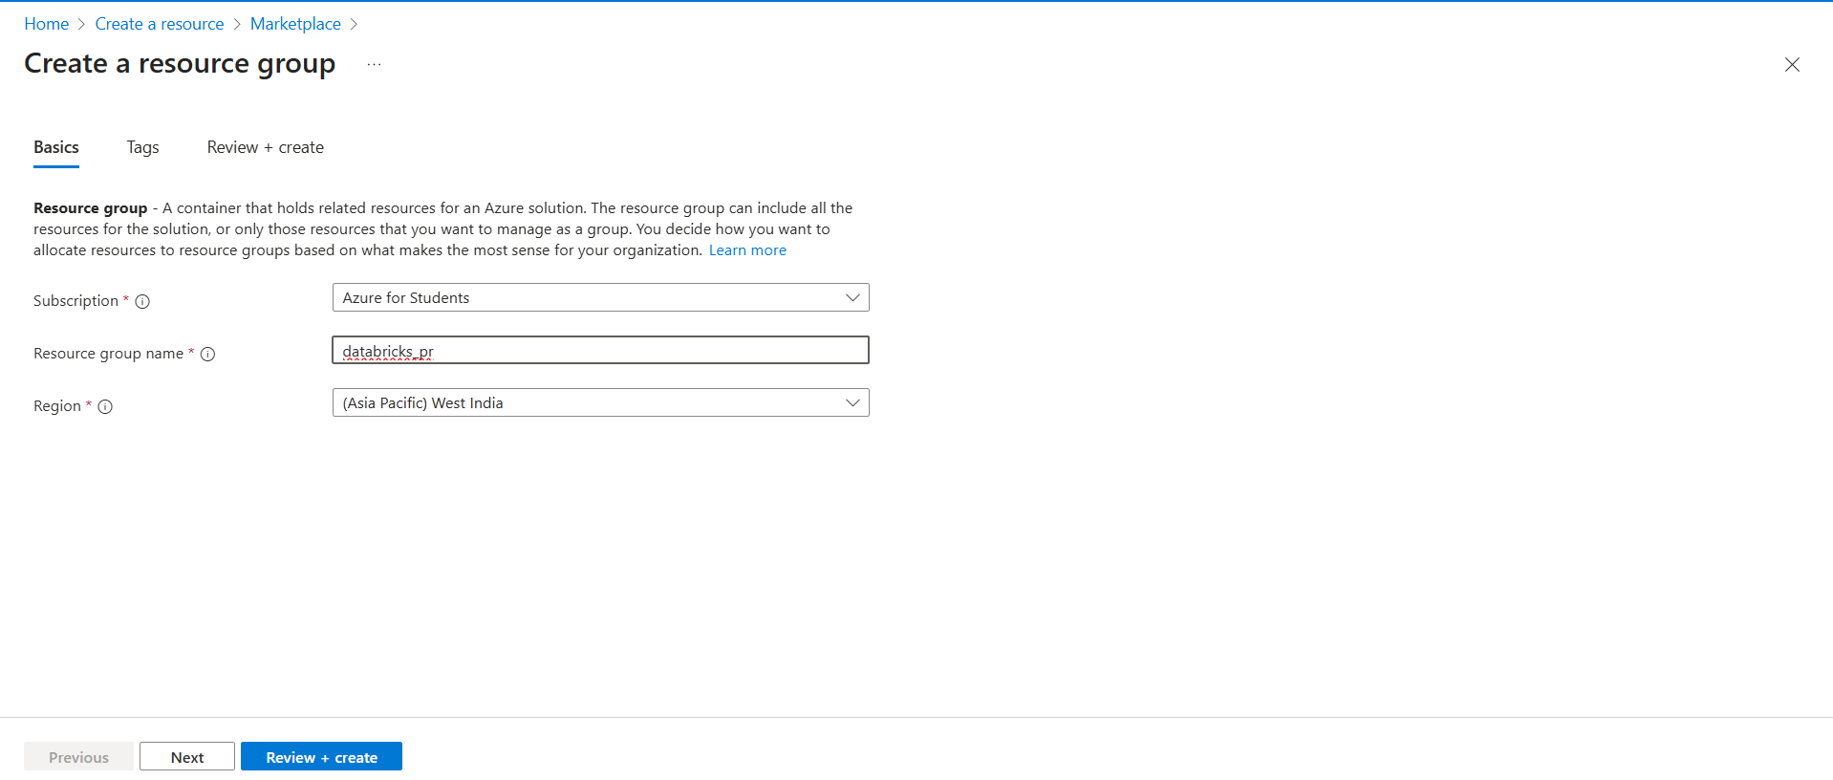

2. Created a storage account in Azure for databricks

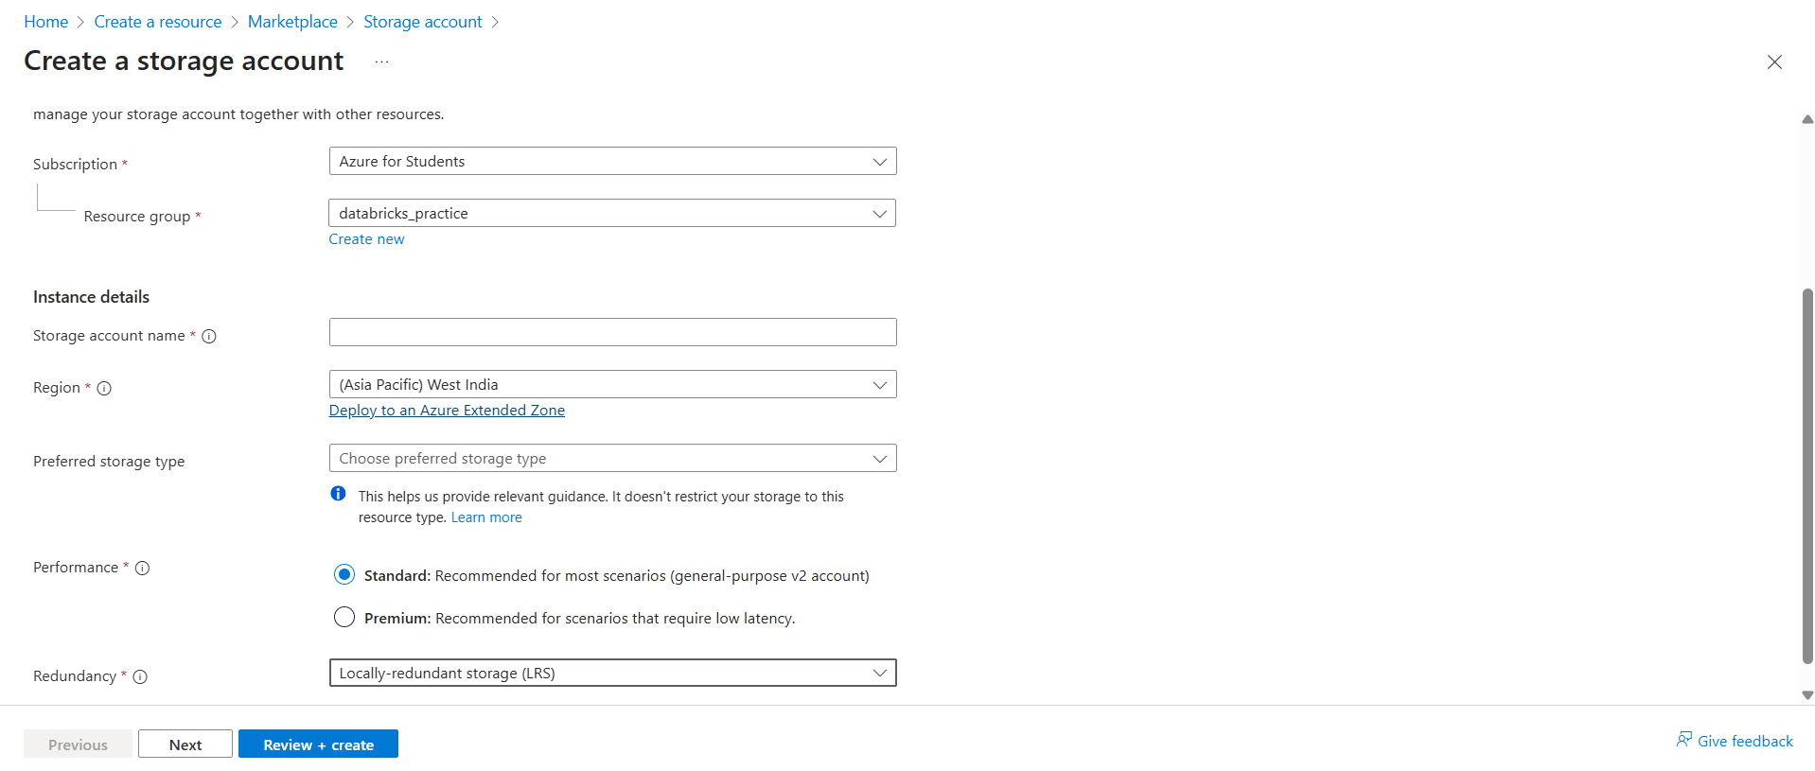

3. Enabled Hierarchical namespace to turn the storage into ADLS Gen2

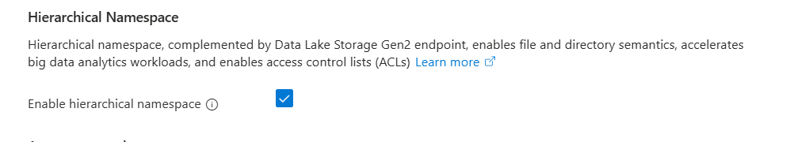

4. Created a Azure Databricks Workspace in the resource group

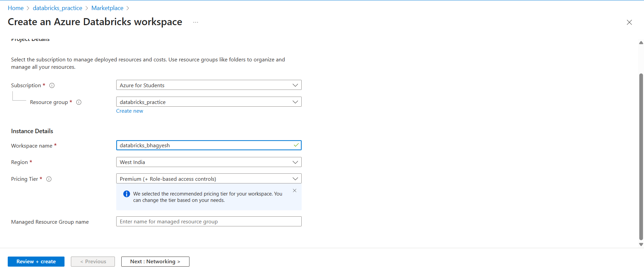

5. Added two containers into data storage (source and destination)

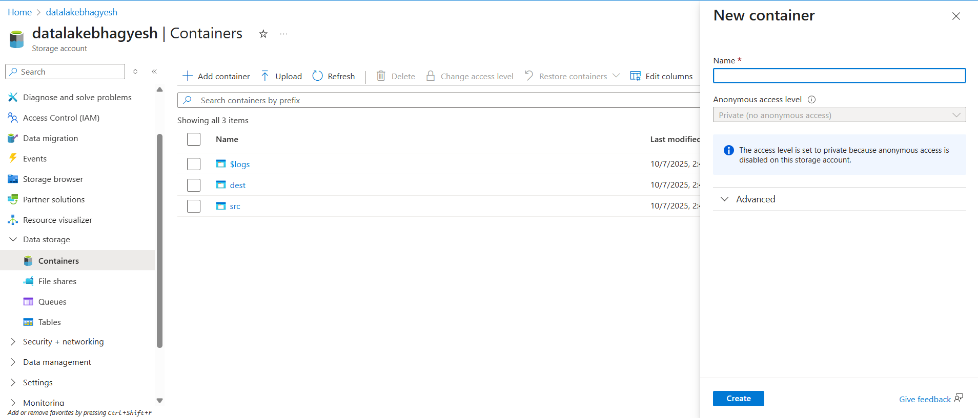

6. Uploaded a csv file into src folder

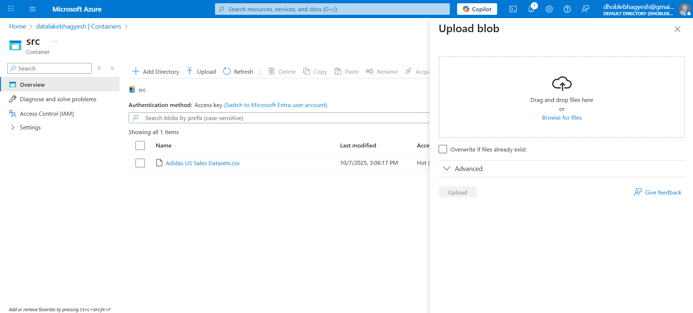

7. Launched Databricks

